**Exploring Weather Trends - Project**

An analysis on the raising temperature trends across the globe, I am based out of Chennai, but considered Bangalore as local city, even though Chennai and Bangalore have varied temperatures, that is the closely city I could arrive in the provided data set. A comparative analysis was done with temperature trends in Bangalore and average global temperature. The following steps were performed to arrive at the observations

**Step 1: Analyse the available data in SQL:**

SQL data provided had three tables,

* city_list - This contains a list of cities and countries in the database. Look through them in order to find the city nearest to you. (Country/ City)
* city_data - This contains the average temperatures for each city by year (ºC). (Year/City/Country/Average Temperature)
* global_data - This contains the average global temperatures by year (ºC) ). (Year/ Average Temperature)

*Note*: The data from city_data is ignored as the same city/country information is available in city_list.

**Step 2: Query the SQL and extract the necessary information**

Performed a left inner join to marry the table’s city_data and global_data for each of the year for which local information is available.

SQL query used:

*Select c.year,c.City,c.avg_temp as Bangalore ,g.avg_temp as Global*

*from city_data c left join global_data g on c.year=g.year*

*where c.city ='Bangalore' order by c.year*

The resulting yearly average data is extracted as an .csv file

**Step 3: Calculate the Moving average**

* Microsoft Excel is used to analyse the .csv file data
* Added new columns – Bangalore and Global to calculate the rolling average
* Used Data Analysis feature of Excel to calculate the moving average with interval as ‘4’ years
* Rolling average provided a smooth increase to the data by taking an average of 4 years rather than actual average temperature
* For few of the years 1811 and 1812, where we data challenge for continues 4 years, the rolling average is calculated with 6 years interval
* Removed the N/A values for the first three years, they will not have a rolling average

**Step 4: Visualizing the Details**

* Line graph is a best illustration for a time series data, as we are comparing the trends across years, used year in x axis and temperature in y axis
* Plotted the temperature trends of both Bangalore and Global in the same graph with two line of different colour

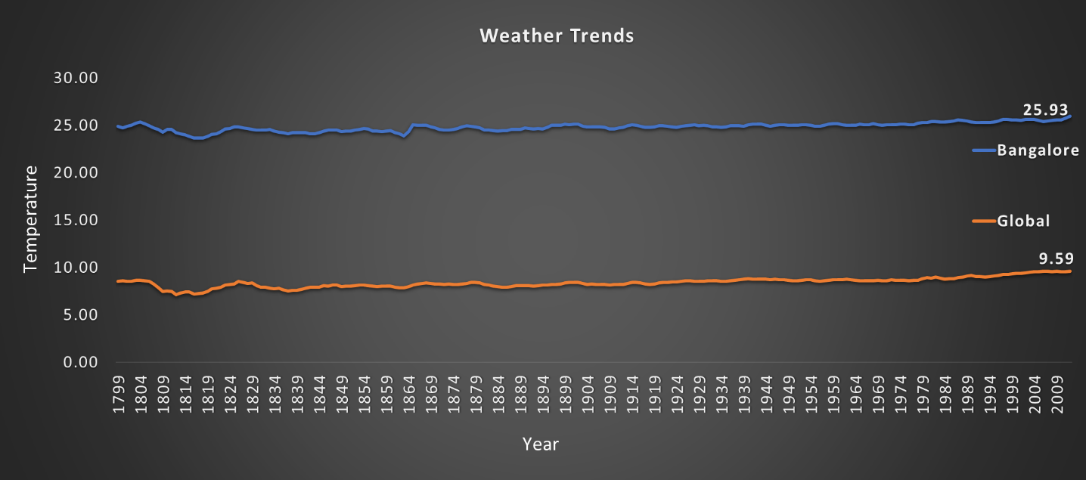

**Observations/Insights:**

1. World has become hotter gradually, in the last 200 years(from 1813 to 2013), there is 24% increase globally and Bangalore has seen 7% increase in temperature
2. Every year, the average temperature raises by 0.5 % globally and Bangalore records 0.7% increase
3. Bangalore is 66% hotter than the average global temperature, the temperature is higher than the average global temperature at all times
4. Bangalore recorded the lowest temperature 23.65 ºC on 1817
5. Global temperature was at the lowest 7.14 ºC on 1813
6. Hottest year for Bangalore is 2013 with 26.61 ºC and global it is 2007 with 9.73 ºC